**AIR TRAFFIC CONTROL**

**Task:**

After years of being an IT student, Kory decided that this job wasn't for him and he was destined to be something greater. He wanted to be like Frank Abagnale Jr, a infamous felon who gained notoriety in the late 1970s by claiming a diverse range of workplace frauds which you can see in the book and movie "Catch me if you can".

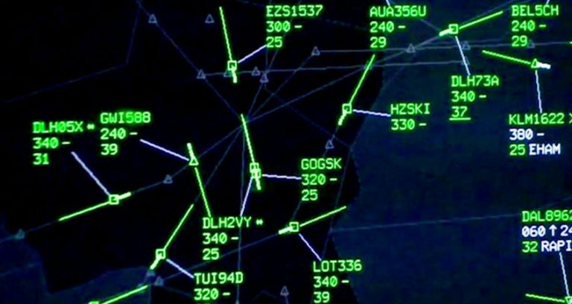As an air traffic controller, Kory's job is to ensure the safe and efficient flow of air traffic within a designated airspace and around airports. His primary responsibility is to prevent collisions between aircraft and provide safe and orderly movement of flights, both in the air and on the ground. Lucky for him, he got the job with no problem thanks to his skillfull talking and charismatic. Unlucky for the people who's on the planes that day because Kory definitely doesn't know how to do his job properly. As his partner in crime, you need to help him find which airplane is going to cause collision knowing that there's only one you need to remove.

**Input:**

The first line of input contains  wps. Each of the  remaining lines describe one line segment with four integers wps all non-negative integers at most wps. The line segment has wps and wps as its endpoints. All endpoints are distinct from each-other.

**Output:**

Output the earliest index within the input of a segment such that removing that segment causes the remaining segments not to intersect.

**Sample**

|  |  |
| --- | --- |
| Input | Output |
| 4  2 1 6 1  4 0 1 5  5 6 5 5  2 7 1 3 | 2 |